

Air Transport

Assessment Cover Page

Student Full Name | Maria Fernanda Quiros H.
Student Number | 2024368
Module Title | Data Visualization
Assessment Title | CA 1
Assessment Due Date | 6th April 2025
Date of Submission | 6th April 2025

Declaration
By submitting this assessment, I confirm that I have read the CCT policy on academic misconduct and understand the implications of submitting work that is not my own or does not appropriately reference material taken from a third party or other source.
I declare it to be my own work and that all material from third parties has been appropriately referenced.
I further confirm that this work has not previously been submitted for assessment by myself or someone else in CCT College Dublin or any other higher education institution.

Contents
1
Air Transport 1
Introduction: 4
Title: Analysis of Air transport Traffic for Route optimization. 5
Subtitle: Analysis Flight Delays: 5
1. Strategic description of the business problem: 5
2. Project plan: 6
3. Business understanding 7
4. Data Understanding 7
5. Data preparation 8
Data exploration 8
Exploratory analysis of the causes of delay. 8
Data processing 10
6. Machine learning implementation 10
7. Findings 11
8. Conclusions: 12
9. Future recommendations: 12
Ethical Considerations 12
References 13

Introduction:
This study follows up on a previous project focused on optimizing air transport routes, expanding the analysis to a critical aspect: commercial flight delays. The main objective is to identify the main causes of flight delays and cancellations, using a structured data set that provides detailed information on delayed flights. This approach seeks to provide useful insights to reduce the factors that negatively impact air transport efficiency.
According to U.S Department of Transportation “This analysis provides information about airline on-time performance, flight delays, and cancellations. It is based on data filed by airlines each month with the Department of Transportation’s Bureau of Transportation Statistics. It covers nonstop operated and marketed scheduled-service flights between points within area”
(Transportation.gov, 2024).
The dataset to be analyzed contains 21 columns organized into different categories: Basic information: Includes data for the year and month of the record (year, month), along with airline and airport codes and names (Carrier, Carrier_name, Airport, Airport_name).
Flight metrics: Details total number of arriving flights (arr_flights), flights with delays greater than 15 minutes (arr_del15), cancelled flights (arr_cancelled) and diverted flights (arr_diverted), as well as total accumulated delay time (arr_delay).
Delay cause: Includes delay counts and durations broken down by category, such as aircraft (Carrier_ct, Carrier_delay), weather (weather_ct, Weather_delay), national system (nas_ct, nas_delay), security (security_ct, security_delay), and other aircraft (late_aircraft_ct, late_aircraft_delay).
The proposed analysis is not limited to describing patterns in the data, but seeks to address the underlying factors of delays using advanced statistical and predictive analysis techniques. This will allow practical solutions to be explored to reduce the most common causes of delays, thus offering useful tools for operational improvement and decision-making in air transport management.
The project will also be organized in two phases, divided into semesters, detailing the key analytical steps, as well as those aspects that will not be considered. In this way, a clear framework is established to complete the analysis and propose strategies based on the results obtained.

All U.S. airlines with at least half of one percent of total domestic scheduled-service passenger revenues plus any branded codeshare partners. Note: For simplicity, statistics are displayed to one decimal place. Actual ranking order is calculated to nine decimal places.

Title: Analysis of Air transport Traffic for Route optimization.

Subtitle: Analysis Flight Delays:

1. Strategic description of the business problem:
Main objective: Identify the factors that contribute to flight delays and provide data-driven solutions to improve punctuality in air transport.
This objective seeks to be able to deepen the analysis of the main causes that cause flight delays in order to predict factors such as:
- Verify if a flight will be delayed more than 15 minutes and the possible causes that influence the event.
- Predict the possible estimated durations of flight delays.

Business impact: Practical solutions to reduce the most common causes of delays, route optimization, improvements in reputation and customer confidence.
This analysis is expected to have a positive impact on airlines by facilitating cost reduction, minimizing delays, optimizing routes and improving sustainability through a reduction in CO2 emissions.
In another aspect, the predictions will allow us to have a better understanding of the main factors that affect airline flights, so this analysis will allow us to delve deeper into the current problem, which will allow us to generate improvements in strategies such as route optimization, communicating possible delays in advance, seeking possible solutions, working together with other departments for continuous improvement in the service.

According to the problem description, we can ask two questions:
What factors such as weather, air traffic or other aircraft delays?
How can possible delays be predicted for route optimization?

2. Project plan:
Scope definition: Analyze the main flight delays in the dataset: Airline_Delay_Cause.csv during 2024 year at the selected airports.
- This project will be developed in 2 semesters, in which the first advance of the problem to be worked on has been presented. In this second advance, the main point will be investigated in depth: flight delays, in which we seek to analyze predictions, patterns and possible areas of improvement.
Project phases:
- - Understanding the business and defining the problem.
- - Data collection, cleaning and exploratory data analysis (EDA).
- - Implementation of a machine learning model to predict delays: Algorithms are used to predict delays and analyze patterns based on historical data. These algorithms detect the probability of delays occurring due to external factors, such as weather conditions or the influence of other airlines.
- - Interpretation of results and recommendations.
Data Sources:
- - Historical data is obtained from transportation.gov
- - Analytical tools: Jupiter Notebook, pandas, Scikit-learn, Matplotlib, among others.
Title | Dataset
Air transport | transportation.gov: https://www.transportation.gov/resources/individuals/aviation-consumer-protection/august-2024-air-travel-consumer-report

3. Business understanding

Sector: Commercial Air Transport.
External factors: Delays and cancellations (Weather, air traffic, security, delays due to previous aircraft)
Impacts of delays: Loss of reputation and customer confidence
Among the impacts of delays, it can be indicated that customer dissatisfaction can be affected by generating an increase in delays, dissatisfaction with the service provided to users also generates an increase in these situations. Logistics problems may also arise on connecting flights between the same aircraft or due to previous aircraft, which promotes greater difficulty in establishing control over delays, among others.

4. Data Understanding

Data sources:
- Transportation.gov databases where you can obtain the dataset of flight delays at the main airports for the last months of 2024, as well as the data can be obtained separately month by month, but for a better analysis, the data for the this year will be studied with the respective reasons that have generated the flight delays.
- Air traffic records and meteorological information.
- Flight delay time.
- Flight metrics: arr_flights: Total number of arrival flights. arr_del15: Total number of flights delayed by more than 15 minutes.
- Causes of the delay: Carrier_ct, weather_ct, nas_ct, security_ct, late_aircraft_ct: count of delays by aircraft, weather, national system, security and delays by other aircraft.
Carrier_delay, weather_delay, nas_delay, security_delay, late_aircraft_delay: Total duration of delays for each cause.
- Others: arr_cancelled, arr_diverted: Cancelled and diverted flights. arr_delay: Total accumulated delay minutes.

5. Data preparation

Data exploration
To prepare the data, we will start by analyzing the main rows and columns, where we can see that the dataset has 1888 entries and a total of 21 columns.
To clean the data, we check if there are null and duplicate values ​​using data.info(), and we can see that there are no missing values.

Exploratory analysis of the causes of delay.
The variables are separated into Causes of delays and durations of delays. The main values ​​are observed: mean, std, min and maximum values ​​where important data are observed such as:
Delayed flights with their respective causes;
Carrier_ct: 24,618 flights.
weather_ct: 3.256
nas_ct: 21.761
security_ct: 0.175
late_aircraft_ct: 29.642034
We can see that the largest number of delayed flights belongs to late_aircraft_ct: delays due to previous aircraft.

Delays in minutes. Overall averages:
Carrier_delay: 1997.2 min
weather_delay: 364.05 min
nas_delay: 1207.16 min
security_delay: 7.84 min
late_aircraft_delay : 2404.90
It can be seen that the longest delays in minutes correspond to late_aircraft_delay: delays by previous airlines with a maximum of 197,739 minutes

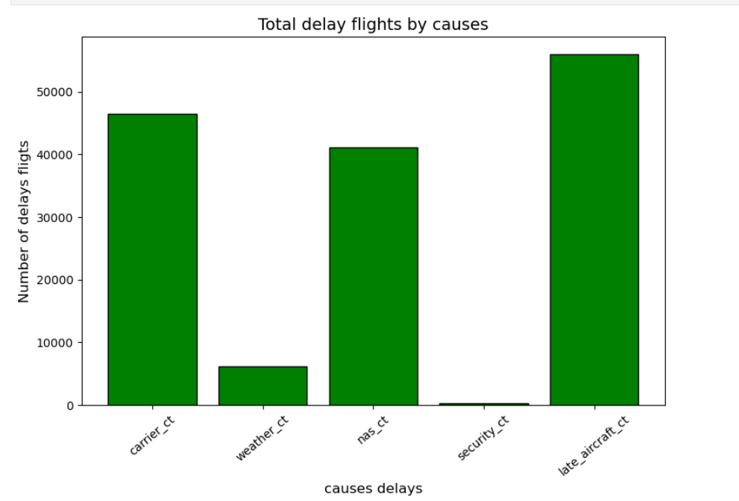
Source: Own elaboration.

The graph shows the delays by cause: It can be observed that delays due to previous aircraft are the most frequent, followed by nas_ct and carrier_ct airlines. Among the less frequent causes are weather and security.

Data processing

At this point, we want to know if a flight will be delayed by more than 15 minutes, so we select (arr_del15) as the target variable.
The variables are coded, converting categorical numerical variables to numerical ones.
After these points, the train test is performed, where we separate the target variable and the independent variables.

6. Machine learning implementation

First model:
Random Forest Classifier:
The Random Forest Classifier model is implemented with the objective of obtaining the prediction of whether a flight will be delayed by more than 15 minutes.
It can be observed that this model only achieves a precision of 22%, which we can interpret as this model only predicts 22% of the cases.
A precision of approximately 22% is quite low, especially if the objective is to predict whether a flight will be delayed. This result indicates that the model is not adequately capturing the relationships between the predictor variables and the target.
Therefore, this model would not be suitable for the case study.
- Another model is selected that is suitable for the analysis, so a change of model and target variable is made.

Second model:
Linear regression:
The linear regression model is implemented in order to obtain the estimated duration of the delays, so the following is used as the target variable: arr_delay.
• Mean absolute error (MAE): Absolute average of the errors.
• Mean square error (MSE): Average of the squared errors.
• R² score: Proportion of the variation explained by the model.

Interpretation of the Results of the Linear Regression Model
Evaluation of Metrics
- Mean absolute error (EMA): The value obtained is 1300.22 minutes. This means that, on average, the model has an absolute error of approximately 1300 minutes in predicting the duration of the delays.
- Mean square error (ME): The value is 9,527,211.90 minutes². It reflects the magnitude of the squared error.
- R² Score: The value obtained is 0.955 (or 95.5%). It indicates that the model explains 95.5% of the variability in the length of delays. This is an excellent result, showing that the model captured well the relationship between the characteristics and the objective.

7. Findings
The main findings observed in this analysis include the main causes of delays, which are related to delays caused by previous aircraft and the national system (NAS), which are the ones that have the most significant impact. However, the causes with the lowest impact or percentage are weather and security.
The findings of the predictive model show that the linear regression model managed to capture 95.5% of the variability in the duration of delays, indicating that the selected characteristics have a strong relationship with the target variable. Delays in the categories of NAS and previous aircraft are those that register the most delays, which could be influencing the model.

8. Conclusions:
This study provides a detailed and structured view of the causes and dynamics behind delays in commercial flights, using historical data and advanced analysis and predictive modeling techniques. The analysis concludes by showing that delays related to previous aircraft are also the longest lasting, averaging 2,404.9 minutes per event. Delays caused by airlines (carrier_delay) and the national system (nas_delay) also have significant durations.

The results highlight the importance of addressing delays related to previous aircraft, as these are not only the most common, but also the longest. Also, improving operational management, optimizing routes and strategically planning schedules could mitigate the most frequent delays and their financial and reputational impacts.
In summary, this analysis allowed us to understand the main causes of delays, as well as having a basis for implementing strategies for route optimization.

9. Future recommendations:

Limitations:
- The data used comes from public sources but may not include all relevant variables for a complete analysis.
- The absence of more extensive or detailed historical data could limit the models and it ability to accurately predict delays under certain conditions.
- Additional factors such as internal airline policies, government regulations will not be considered.
To improve the analysis, it is recommended to record additional data on air traffic, airport size, and specific circumstances for each delay, as well as to use other models or optimization of the models. Conduct more detailed studies and analysis by region, airport, or season to identify local patterns in delays. Use predictive air traffic tools to identify congested and less saturated schedules.
Among the possible solutions for future improvements in the business, recommendations such as real-time monitoring systems, strategies for reducing the time of connecting flights, however with reasonable time to avoid further delays due to operational management or supply. Identification of alternate routes and congested schedules that may affect other airlines and therefore generate delays to the business. Work together with NAS.

Timeline

1 semester
1 trimester | 2 trimester
Data collection: The data sources will be used to gather historical data, which will enable analysis and visualisation. “Exploratory Data Analysis (EDA) will help analyse the data appropriately, avoiding assumptions, identifying errors, and visualizing the data” (OpenAI, 2024).  Data cleaning: It is crucial to ensure that the data being used is accurate and complete during the cleaning process. This aims to eliminate incomplete records. | Exploration and analysis: Exploratory Data Analysis (EDA) where charts can be used to visualize potential patterns.  Identify routes with the highest traffic or congestion, as well as external factors such as weather conditions.

2 semester
- Month | Advanced analysis: During this period, data analysis will be explored in depth.
- Month | Model development: Algorithms will be used to optimize routes and suggest improvements for flights.
- Month | Model evaluation: Proceed with evaluating the models used to identify patterns, delays, cancellations, distribution, and the models used to estimate CO2 emissions.
- Month | Visualization in tools that allow data exploration: Maps will be used to visualize routes with the highest traffic.
- Month | Predictions.  Solutions and recommendations based on the results obtained from the data analysis
- Month | Interpretation of results and report generation: Project impact such as improvements in punctuality.  Presentation of the final project

Ethical Considerations

This project does not involve medical data, and it respects confidentiality and user privacy. It utilizes publicly available data. Transparency in data usage is a priority. Only the information necessary for research and analysis will be used. Quotes, images, and references will be provided in accordance with Harvard referencing guidelines.

References

Bureau of Transportation Statistics (2024) Understanding the Reporting of Causes of Flight Delays and Cancellations. Available at: https://www.bts.gov/topics/airlines-and-airports/understanding-reporting-causes-flight-delays-and-cancellations#q1 (Accessed: 7 December 2024).
OpenAI. (2023). ChatGPT (Mar 14 version) [Large language model].
https://chatgpt.com/share/6713ac1e-146c-8010-99d8-92db0e4ce236
https://chatgpt.com/share/671d2884-57b0-8010-8f06-8f90c26c3fe8
U.S Department of transportation(2024) August 2024 Air Travel Consumer Report. Available at: https://www.transportation.gov/resources/individuals/aviation-consumer-protection/august-2024-air-travel-consumer-report (Accessed: 5 December 2024).
Github: https://github.com/Mariferq05/Caso-proposal/commits/main/

